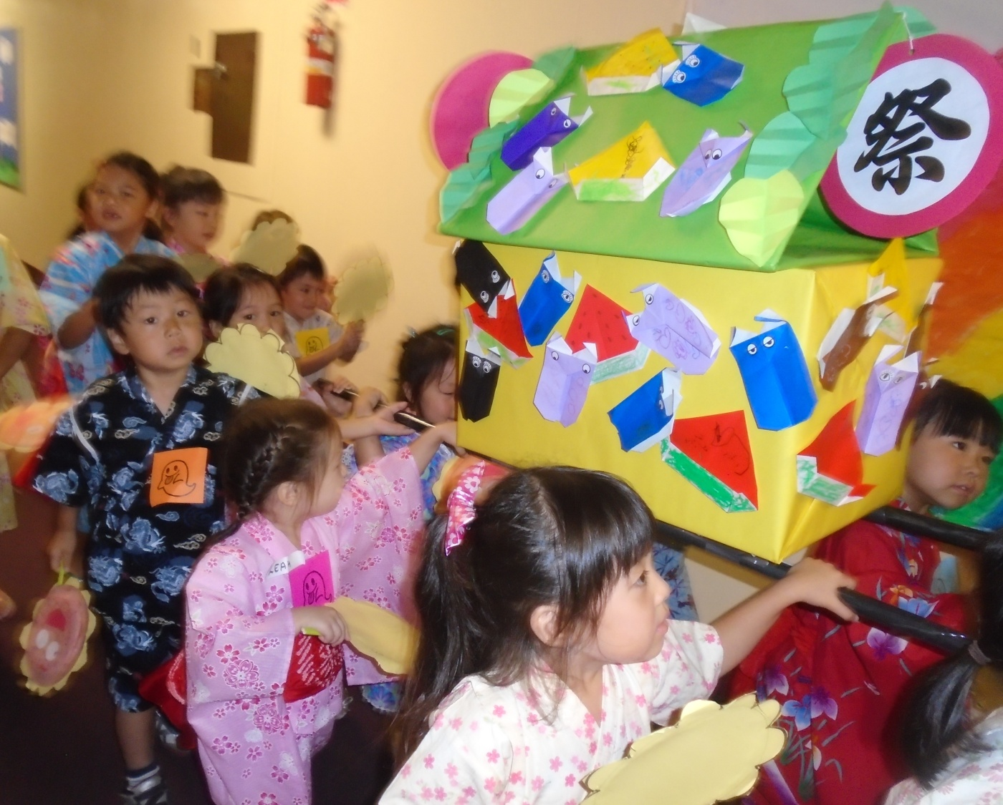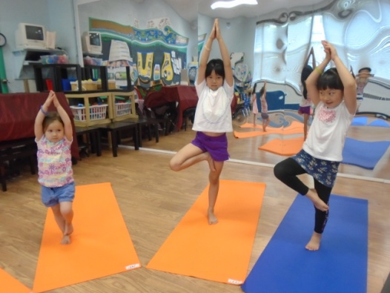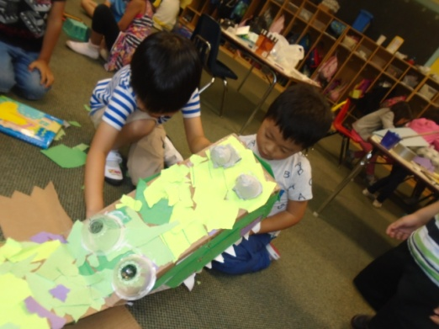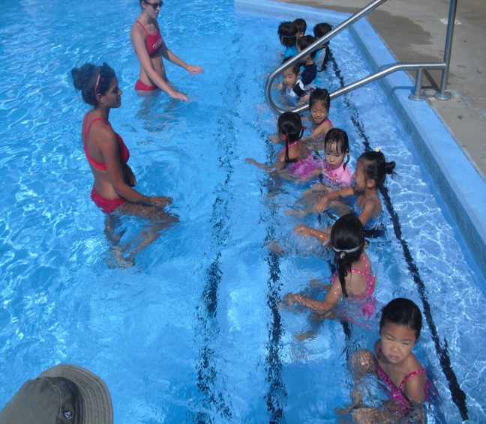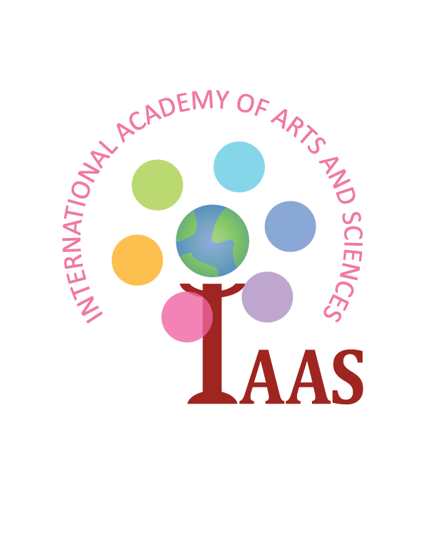

**International Academy of Arts and Sciences**

**300 High Street, *Closter NJ* 07624 / (201)767-1144**

**Email: info@asunarokokusai.org**

**Check Out Our Blog! http://asunarokokusai.blogspot.com**